Eating and Drinking Worthily

“Worthy is the Lamb that was slain to receive power, and riches, and wisdom, and strength, and honor, and glory,
and blessing.” Revelation 5:12

“. . .whoever eats the bread or drinks the cup of the Lord in an unworthy manner, shall be guilty of the body and the blood of the Lord.” 1 Corinthians 11:27 NAS
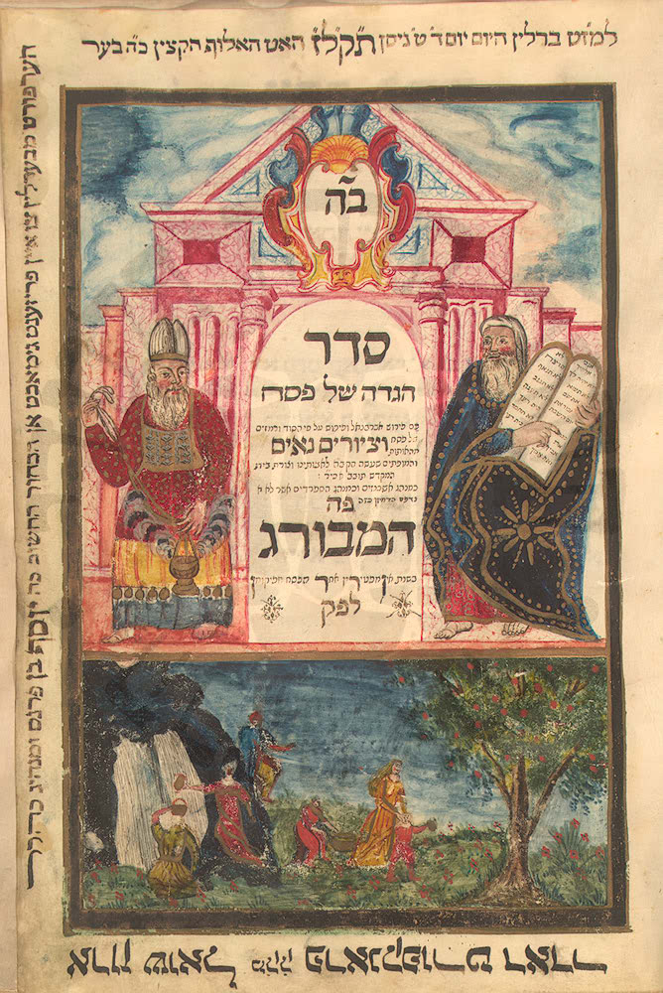
“Searching for Chametz [leaven] involves more than removing every particle of physical leaven from our domain; it also means eradicating every last vestige of spiritual leaven—self-inflating pride—from every ‘recess and crevice’ of one’s … self.’

A Jewish prayer regarding the Leaven: “May all manner of leaven in my possession, whether I have seen it or not, or whether I have removed it or not, be hereby annulled and considered dust of the earth.”

“Search me, O God, and know my heart: try me, and know my thoughts: And see if there be any wicked way in me, and lead me in the way everlasting.”
Passover Hagaddah
Psalm 139:23-24

“Clean out the old leaven, that you may be a new lump, just as you are in fact unleavened. For Christ our Passover also has been sacrificed. Let us therefore celebrate the feast, not with old leaven, nor with the leaven of malice and wickedness, but with the unleavened bread of sincerity and truth.” 1 Cor.5:7,8

“Let us draw near to God with a sincere heart in full assurance of faith, having our hearts sprinkled to cleanse us from a guilty conscience… Hebrews 10:22

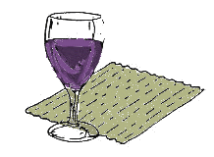
Portion of the Hallel read at Jewish Passover: “The stone which the builders refused is become the head stone of the corner. . . . bind the sacrifice with cords, even unto the horns of the altar.” Psalm 118:22, 27

“O my Father, if it be possible, let this cup pass from me: nevertheless not
as I will, but as thou wilt.” Matt 26:39

At 3 pm : The time of the evening sacrifice …and Jesus said “it is finished”… “Father, into thy hands I commend my spirit.”

My Search For The Leaven In My Heart

Father, Holy One I come to Thee, in Jesus’ Name
And find myself again on bended knee.
To purify my heart and mind—my plea the same
To find and burn away the leaven—for which I search.

Sin’s frailty revealed in each leavened crumb,
Reminders of careless thoughts unchecked.
Surmisings percolated, boiled over face and
Tongue unguarded blurted injury—all to hear.

Advocate, Lord Jesus, beside me stand
Offer up with holy incense again my supplication
Accept my heart and tears you see
Search me, renew me, restore me.

How long before a promised robe of white
Will mark intentions unencumbered by sin?

If We’d Known

We did not hear with understanding
When in the upper room we gathered
Our last Passover there partaking
Preparation for our straitened journey.

When you said, “With desire
Have I desired to eat this Passover
With you before I suffer.”
We did not hear with understanding.

Lord Jesus, how did we miss
An opportunity so rare? How could we not
See your need? No one among us all,
Was there to comfort you.
We came all self-possessed
Yet not a one stooped down, nor
Reached our hands to wash from you
The dusty streets of Jerusalem.

No, you with all upon your mind
Prepared one lesson more,
And you upon your bended knee
Did serve us shamelessly.

Where was our humility that moonlit night?
Buried was it beneath our pride?
If no humility. . .where was our compassion
When you were all too soon to die?
With bread and cup in hand you held
Your blessings richly spoken,
Oh, if we had known more then
Would we have stronger been?
Or would we have slept as did the three
When you had urged them--watch!
They sad and worn within Gethsemane
Were they not the same as we?

Knowing more, would we still
Have fled, denied, and cried? And then
Sadly, gladly met thee. . .risen.
Had we known more and understood?

What would we have done
If we had known your chief desire
Before the dreaded deed was done
What could we have done, but interrupt...
What could we have done, but interrupt!

